

**PRACTICAL FILE OF OPERATING SYSTEM**

## BTech: III Year

Department of Computer Science & Information Technology

**Name of the Student : Aakash Chouhan**

**Branch & section: CSIT – 01**

**Roll No.: 0827CI201002**

**Year: III Year**

## Department of Computer Science & Information Technology

**AITR, Indore,**

**ACROPOLIS INSTITUTE OF TECHNOLOGY & RESEARCH, INDORE**

# Department of Computer Science & Information Technology

**Certificate**

This is to certify that the experimental work entered in this journal as per the BTech III year syllabus prescribed by the RGPV was done by Mr. / Ms.Aakash Chouhan ..in …5th… semester in the Laboratory of this institute during the academic year 2022….- 2022…...

Signature of Head Signature of the Faculty

### ACROPOLIS INSTITUTE OF TECHNOLOGY & RESEARCH, INDORE GENERAL INSTRUCTIONS FOR LABORATORY CLASSES

**DO’S**

* Without Prior permission do not enter into the Laboratory.
* While entering into the LAB students should wear their ID cards.
* The Students should come with proper uniform.
* Students should maintain silence inside the laboratory.
* After completing the laboratory exercise, make sure to shutdown the system properly.

**DONT’S**

* Students bringing the bags inside the laboratory.
* Students using the computers in an improper way.
* Students scribbling on the desk and mishandling the chairs.
* Students using mobile phones inside the laboratory.
* Students making noise inside the laboratory.

### **SYLLABUS**

#### CS-502 – Operating System

**Branch:** Computer Science & Information Technology V Semester

**Course:** CSIT 502 Operating System

#### Unit I

Introduction to System Programs & Operating Systems, Evolution of Operating System (mainframe, desktop, multiprocessor, Distributed, Network Operating System, Clustered & Handheld System), Operating system services, Operating system structure, System Call & System Boots, Operating system design & Implementations, System protection, Buffering & Spooling. Types of Operating System: Bare machine, Batch Processing, Real Time, Multitasking & Multiprogramming, time-sharing system.

#### Unit II

File: concepts, access methods, free space managements, allocation methods, and directory systems, protection, organization ,sharing & implementation issues, Disk & Drum Scheduling, I/0 devices organization, I/0 devices organization, I/0 buffering, I/O Hardware, Kernel I/O subsystem, Transforming I/O request to hardware operations. Device Driver: Path managements, Sub module, Procedure, Scheduler, Handler, Interrupt Service Routine. File system in Linux & Windows

#### Unit III

Process: Concept, Process Control Blocks (PCB), Scheduling criteria Preemptive & non Preemptive process scheduling, Scheduling algorithms, algorithm evaluation, multiple processor scheduling, real time scheduling, operations on processes, threads; inter process communication, precedence graphs, critical section problem, semaphores, and classical problems of synchronization. Deadlock: Characterization, Methods for deadlock handling, deadlock prevention, deadlock avoidance, deadlock detection, recovery from deadlock, Process Management in Linux.

#### Unit IV

Memory Hierarchy, Concepts of memory management, MFT & MVT, logical and physical address space, swapping, contiguous and non-contiguous allocation, paging, segmentation, and paging combined with segmentation. Structure & implementation of Page table. Concepts of virtual memory, Cache Memory Organization, demand paging, page replacement algorithms, allocation of frames, thrashing, and demand segmentation.

#### Unit V

Distributed operating system:-Types, Design issues, File system, Remote file access, RPC, RMI, Distributed Shared Memory(DSM), Basic Concept of Parallel Processing & Concurrent Programming Security & threats protection: Security violation through Parameter, Computer Worms & Virus, Security Design Principle, Authentications, Protection Mechanisms. introduction to Sensor network and parallel operating system. Case study of Unix, Linux & Windows

### HARDWARE REQUIREMENTS:

Processors - 2.0 GHz or Higher RAM - 256 MB or Higher Hard Disk - 20 GB or Higher

### SOFTWARE REQUIREMENTS:

Linux: Ubuntu / OpenSUSE / Fedora / Red Hat / Debian / Mint OS WINDOWS: XP/7

Linux could be loaded in individual PCs.

### RATIONALE:

The purpose of this subject is to cover the underlying concepts Operating System .This syllabus provides a comprehensive introduction of Operating System, Process Management, Memory Management, File Management and I/O management.

### PREREQUISITE:

The students should have general idea about Operating System Concept, types of Operating System and their functionality.

**Lab Plan Operating System CSIT-502**

|  |  |  |
| --- | --- | --- |
| **S.No** | **Name of Experiment** | **Page No.** |
| 1. | Program to implement FCFS scheduling | 1 |
| 2. | Program to implement SJF scheduling | 6 |
| 3. | Program to implement SRTF scheduling | 11 |
| 4. | Program to implement Round Robin scheduling | 16 |
| 5. | Program to implement Priority scheduling | 22 |
| 6. | Program to implement Banker’s algorithm | 28 |
| 7. | Program to implement FIFO page replacement algorithm. | 34 |
| 8. | Program to implement LRU page replacement algorithm | 39 |
| 9 | Program to implement Disk Scheduling(FIFO) algorithm | 44 |
| 10 | Program to implement Disk Scheduling(SSTF) algorithm | 49 |

**ACROPOLIS INSTITUTE OF TECHNOLOGY & RESEARCH, INDORE**

# Name of Department------------Name of Laboratory------------

**Index**

|  |  |  |  |  |  |
| --- | --- | --- | --- | --- | --- |
| S.No. | Date of Exp. | Name of the Experiment | Page No. | Date of Submission | Grade & Sign of the Faculty |
| 1. |  |  |  |  |  |
| 2. |  |  |  |  |  |
| 3. |  |  |  |  |  |
| 4. |  |  |  |  |  |
| 5. |  |  |  |  |  |
| 6. |  |  |  |  |  |
| 7. |  |  |  |  |  |
| 8. |  |  |  |  |  |
| 9. |  |  |  |  |  |
| 10. |  |  |  |  |  |
| 11. |  |  |  |  |  |

# Experiment-1

## FCFS SCHEDULING

|  |  |  |  |  |  |
| --- | --- | --- | --- | --- | --- |
| Name of Student: Aakash Chouhan | | | | Class: B.tech | |
| Enrollment No:0827CI201002 | | | | Batch: 2020-2024 | |
| Date of Experiment | Date of Submission | | | | Submitted on: |
| Remarks by faculty: | | | Grade: | | |
| Signature of student: | | Signature of Faculty: | | | |

**OBJECTIVE OF THE EXPERIMENT**

To write c++ program to implement the FCFS SCHEDULING.

## FACILITIES REQUIRED

1. **Facilities Required Doing The Experiment:**

|  |  |  |
| --- | --- | --- |
| **S.NO** | **FACILITIES REQUIRED** | **QUANTITY** |
| **1** | **System** | **1** |
| **2** | **WINDOWS XP/7** |  |

## Concept of FCFS:

* Jobs are executed on first come, first serve basis.
* Easy to understand and implement.
* Poor in performance as average wait time is high.

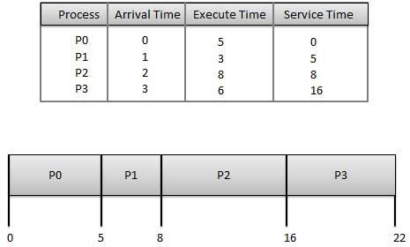

## Algorithm:

Step 1: Start the process

Step 2: Accept the number of processes in the ready Queue

Step 3: For each process in the ready Q, assign the process id and accept the CPU burst time Step 4: Set the waiting of the first process as ‘0’ and its burst time as its turn around time Step 5: for each process in the Ready Q calculate

* 1. Waiting time for process(n)= waiting time of process (n-1) + Burst time of process(n- 1)
  2. Turn around time for Process(n)= waiting time of Process(n)+ Burst time for process(n)

Step 6: Calculate

1. Average waiting time = Total waiting Time / Number of process
2. Average Turnaround time = Total Turnaround Time / Number of process Step 7: Stop the process

## Program:

**WITH VARRYING ARRIVAL TIME**

|  |
| --- |
|  |
| #include <iostream> |
|  |  |
|  | class FCFS |
|  | { |
|  | public: |
|  | void completion(int procesid[],int n,int bursttime[],int comp[]) |
|  | { |
|  | comp[0]=bursttime[0]; |
|  | for(int i=1;i<n;i++) |
|  | { |
|  | comp[i]=comp[i-1]+bursttime[i]; |
|  | } |
|  | } |
|  |  |
|  | void turnaround_time(int procesid[],int n,int bursttime[],int tat[],int comp[],int arrivaltime[]) |
|  | { |
|  |  |
|  | for(int i=0;i<n;i++) |
|  | { |
|  | tat[i]=comp[i]-arrivaltime[i]; |
|  | } |
|  | } |
|  | void waiting_time(int procesid[],int n,int bursttime[],int tat[],int wait[]) |
|  | { |
|  | for(int i=0;i<n;i++) |
|  | { |
|  | wait[i]=tat[i]-bursttime[i]; |
|  | } |
|  | } |
|  | void display(int procesid[],int comp[],int tat[],int wait[],int n,int arrivaltime[],int bursttime[]) |
|  | { |
|  | cout<<"p_ID arrival burst completion TAT Waiting"<<endl; |
|  | for(int i=0;i<n;i++) |
|  | { |
|  | cout<<procesid[i]<<" "<<arrivaltime[i]<<" "<<bursttime[i]<<" " <<comp[i]<<" "<<tat[i]<<" "<<wait[i]<<endl; |
|  | } |
|  | } |
|  | }; |
|  | int main() |
|  | { |
|  | FCFS f; |
|  | int n; |
|  | cout<<"Enter the number of process:"; |
|  | cin>>n; |
|  | int procesid[n]; |
|  | int bursttime[n]; |
|  | int arrivaltime[n]; |
|  | for(int i=0;i<n;i++) |
|  | { |
|  | cout<<"Enter the process ID "<<endl; |
|  | cin>>procesid[i]; |
|  | } |
|  | for(int i=0;i<n;i++) |
|  | { |
|  | cout<<"Enter the arrival time and burst time of Process :"<<i+1<<endl; |
|  | cin>>arrivaltime[i]>>bursttime[i]; |
|  | } |
|  | int comp[n]; |
|  | int tat[n]; |
|  | int wait[n]; |
|  |  |
|  | f. completion( procesid, n, bursttime,comp); |
|  |  |
|  |  |
|  | f.turnaround_time( procesid, n, bursttime, tat,comp,arrivaltime); |
|  | f.waiting_time( procesid, n, bursttime, tat,wait); |
|  | f.display( procesid,comp,tat, wait, n,arrivaltime,bursttime); |
|  |  |
|  | return 0; |
|  | } |
|  |  |

**WITH ZERO ARRIVAL TIME**

|  |
| --- |
| #include <iostream> |
|  | using namespace std; |
|  | class FCFS |
|  | { |
|  | public: |
|  | void completion(int procesid[],int n,int bursttime[],int comp[]) |
|  | { |
|  | comp[0]=bursttime[0]; |
|  | for(int i=1;i<n;i++) |
|  | { |
|  | comp[i]=comp[i-1]+bursttime[i]; |
|  | } |
|  | } |
|  |  |
|  | void turnaround_time(int procesid[],int n,int bursttime[],int tat[],int comp[]) |
|  | { |
|  |  |
|  | for(int i=0;i<n;i++) |
|  | { |
|  | tat[i]=comp[i]; |
|  | } |
|  | } |
|  | void waiting_time(int procesid[],int n,int bursttime[],int tat[],int wait[]) |
|  | { |
|  | for(int i=0;i<n;i++) |
|  | { |
|  | wait[i]=tat[i]-bursttime[i]; |
|  | } |
|  | } |
|  | void display(int procesid[],int comp[],int tat[],int wait[],int n) |
|  | { |
|  | cout<<"p_ID completion TAT Waiting"<<endl; |
|  | for(int i=0;i<n;i++) |
|  | { |
|  | cout<<procesid[i]<<" " <<comp[i]<<" "<<tat[i]<<" "<<wait[i]<<endl; |
|  | } |
|  | } |
|  | }; |
|  | int main() |
|  | { |
|  | FCFS f; |
|  | int n; |
|  | cout<<"Enter the number of process:"; |
|  | cin>>n; |
|  | int procesid[n]; |
|  | int bursttime[n]; |
|  | // int arr[n]={0}; |
|  | for(int i=0;i<n;i++) |
|  | { |
|  | cout<<"Enter the process ID and burst time:"; |
|  | cin>>procesid[i]>>bursttime[i]; |
|  | } |
|  | int comp[n]; |
|  | int tat[n]; |
|  | int wait[n]; |
|  |  |
|  | f. completion( procesid, n, bursttime,comp); |
|  |  |
|  |  |
|  | f.turnaround_time( procesid, n, bursttime, tat,comp); |
|  | f.waiting_time( procesid, n, bursttime, tat,wait); |
|  | f.display( procesid,comp,tat, wait, n); |
|  |  |
|  | return 0; |
|  | } |

**e)Output:**

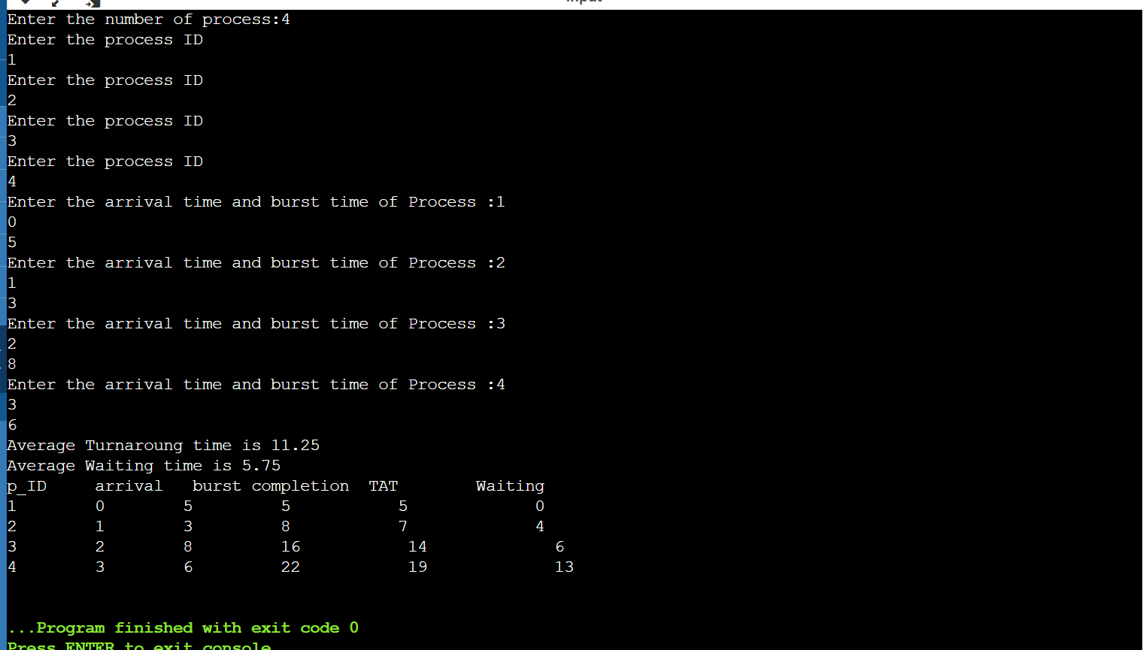

## Result:

Average Waiting Time = 5.75

Average Turnaround Time = 11.25

# Experiment-2

## SJF Scheduling

|  |  |  |  |  |  |
| --- | --- | --- | --- | --- | --- |
| Name of Student: Aakash Chouhan | | | | Class: B.tech | |
| Enrollment No:0827CI201002 | | | | Batch: 2020-2024 | |
| Date of Experiment | Date of Submission | | | | Submitted on: |
| Remarks by faculty: | | | Grade: | | |
| Signature of student: | | Signature of Faculty: | | | |

**OBJECTIVE OF THE EXPERIMENT**

To write c++ program to implement SJF CPU Scheduling Algorithm.

## FACILITIES REQUIRED

1. **Facilities Required Doing The Experiment:**

|  |  |  |
| --- | --- | --- |
| **S.NO** | **FACILITIES REQUIRED** | **QUANTITY** |
| **1** | **System** | **1** |
| **2** | **WINDOWS XP/7** |  |

## Concept of SJF:

* Best approach to minimize waiting time.
* Processer should know in advance how much time process will take.

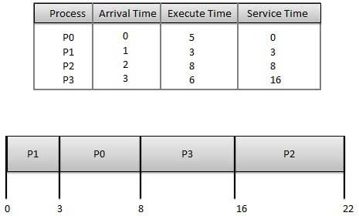

## Algorithm:

Step 1: Start the process

Step 2: Accept the number of processes in the ready Queue

Step 3: For each process in the ready Q, assign the process id and accept the CPU burst time Step 4: Start the Ready Q according the shortest Burst time by sorting according to lowest to highest burst time.

Step 5: Set the waiting time of the first process as ‘0’ and its turnaround time as its burst time.

Step 6: For each process in the ready queue, calculate

1. Waiting time for process(n)= waiting time of process (n-1) + Burst time of process(n- 1)
2. Turnaround time for Process(n)= waiting time of Process(n)+ Burst time for process(n)

Step 7: Calculate

1. Average waiting time = Total waiting Time / Number of process
2. Average Turnaround time = Total Turnaround Time / Number of process Step 8: Stop the process

## Program:

**WITH ARRIVAL TIME**

#include <bits/stdc++.h>

using namespace std;

struct data

{

int pid;

int bt;

int at;

int wt;

int tat;

};

bool cmp( data x , data y)

{

return ( x.bt<y.bt);

}

int main()

{

data a[30];

int i,k,n;

float wtavg , tatavg;

float avgwt,avgtat;

cout<<"Enter the Number of process"<<endl;

cin>>n;

for(i=0;i<n;i++)

{

a[i].pid =i;

//a[i].at=0;

cout<<"Enter The Burst time for the process "<<i<<endl;

cin>>a[i].bt;

cout<<"Enter The Arrival time for the process "<<i<<endl;

cin>>a[i].at;

}

sort( a , a+n , cmp);

a[0].wt =0;

a[0].tat = a[0].bt;

for(i=1;i<n;i++)

{

a[i].wt = a[i-1].wt + a[i-1].bt;

a[i].tat = a[i-1].tat + a[i].bt;

}

cout<<endl<<"P.id\tAt\tBt\tWt\tTat"<<endl;

for(i=0;i<n;i++)

{

avgwt=avgwt+a[i].wt;

avgtat=avgtat+a[i].tat;

cout<<a[i].pid<<"\t"<<a[i].at<<"\t"<<a[i].bt<<"\t"<<a[i].wt<<"\t"<<a[i].tat<<endl;

}

avgwt=avgwt/n;

avgtat=avgtat/n;

cout<<"Average waiting time:"<<avgwt<<endl;

cout<<"Average turn around time time:"<<avgtat<<endl;

};

1. **Output:**

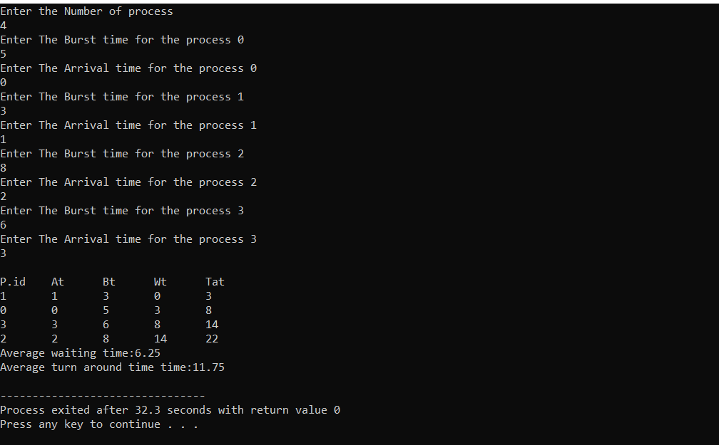

## Result:

Average Waiting Time : 6.25

Average Turnaround Time : 8

# Experiment-3

|  |  |  |  |  |  |
| --- | --- | --- | --- | --- | --- |
| P1 | P2 | P3 | P2 | P4 | P1 |

## SRTF Scheduling

|  |  |  |  |  |  |
| --- | --- | --- | --- | --- | --- |
| Name of Student: Aakash Chouhan | | | | Class: B.tech | |
| Enrollment No:0827CI201002 | | | | Batch: 2020-2024 | |
| Date of Experiment | Date of Submission | | | | Submitted on: |
| Remarks by faculty: | | | Grade: | | |
| Signature of student: | | Signature of Faculty: | | | |

**OBJECTIVE OF THE EXPERIMENT**

To write c program to implement SRTF scheduling.

## FACILITIES REQUIRED

1. **Facilities Required To Do The Experiment:**

|  |  |  |
| --- | --- | --- |
| **S.NO** | **FACILITIES REQUIRED** | **QUANTITY** |
| **1** | **System** | **1** |
| **2** | **Windows XP/7** |  |

## Concept Of SRTF Scheduling:

* Associate with each process the length of its next CPU burst. Use these lengths to schedule the process with the shortest time.
* Two schemes:
* 1. non pre- emptive – once CPU given to the process it cannot be preempted until completes its CPU burst.
* 2. Preemptive – if a new process arrives with CPU burst length less than remaining time of current executing process, preempt. This scheme is known as the Shortest-Remaining- Time-First (SRTF).

Example of Preemptive SJF

|  |  |  |  |  |  |  |
| --- | --- | --- | --- | --- | --- | --- |
|  | Process | Arrival Time |  | Burst Time |  | |
| P1 | 0.0 |  | 7 |  |  |
| P2 | 2.0 |  | 4 |  |  |
| P3 | 4.0 |  | 1 |  |  |
| P4 | 5.0 |  | 4 |  |  |
| SJF (preemptive) |  |  |  |  |  |
|  |  |  |  |  |  |  |
| 0 | 2 | 4 | 5 | 7 | 11 | 16 |

## Algorithm:

Step 1: Start the process

Step 2: Accept the number of processes in the ready Queue

Step 3: For each process in the ready Q, assign the process id and accept the CPU burst time Step 4: For each process in the ready Q, Accept Arrival time

Step 4: Start the Ready Q according the shortest Burst time by sorting according to lowest to Highest burst time.

Step 5: Set the waiting time of the first process in Sorted Q as ‘0’.

Step 6: After every unit of time compare the remaining time of currently executing process (RT) and Burst time of newly arrived process (BTn).

Step 7: If the burst time of newly arrived process (BTn) is less than the currently executing process (RT) the processor will preempt the currently executing process and starts executing newly arrived process

Step 7: Calculate

1. Average waiting time = Total waiting Time / Number of process
2. Average Turnaround time = Total Turnaround Time / Number of process Step 8: Stop the process

## Program:

#include <bits/stdc++.h>

using namespace std;

struct Process {

    int pid; // Process ID

    int bt; // Burst Time

    int art; // Arrival Time

};

void findWaitingTime(Process proc[], int n,

                                int wt[])

{

    int rt[n];

    for (int i = 0; i < n; i++)

        rt[i] = proc[i].bt;

    int complete = 0, t = 0, minm = INT_MAX;

    int shortest = 0, finish_time;

    bool check = false;

    while (complete != n) {

        for (int j = 0; j < n; j++) {

            if ((proc[j].art <= t) &&

            (rt[j] < minm) && rt[j] > 0) {

                minm = rt[j];

                shortest = j;

                check = true;

            }

        }

        if (check == false) {

            t++;

            continue;

        }

                rt[shortest]--;

        minm = rt[shortest];

        if (minm == 0)

            minm = INT_MAX;

               if (rt[shortest] == 0) {

            complete++;

            check = false;

            finish_time = t + 1;

            wt[shortest] = finish_time -

                        proc[shortest].bt -

                        proc[shortest].art;

            if (wt[shortest] < 0)

                wt[shortest] = 0;

        }

        t++;

    }

}

void findTurnAroundTime(Process proc[], int n,

                        int wt[], int tat[])

{

    for (int i = 0; i < n; i++)

        tat[i] = proc[i].bt + wt[i];

}

void findavgTime(Process proc[], int n)

{

    int wt[n], tat[n], total_wt = 0,

                    total_tat = 0;

    findWaitingTime(proc, n, wt);

    findTurnAroundTime(proc, n, wt, tat);

    cout << " P\t\t"

        << "BT\t\t"

        << "WT\t\t"

        << "TAT\t\t\n";

    for (int i = 0; i < n; i++) {

        total_wt = total_wt + wt[i];

        total_tat = total_tat + tat[i];

        cout << " " << proc[i].pid << "\t\t"

            << proc[i].bt << "\t\t " << wt[i]

            << "\t\t " << tat[i] << endl;

    }

    cout << "\nAverage waiting time = "

        << (float)total_wt / (float)n;

    cout << "\nAverage turn around time = "

        << (float)total_tat / (float)n;

}

int main()

{

    Process proc[] = { { 1, 6, 2 }, { 2, 2, 5 },

                    { 3, 8, 1 }, { 4, 3, 0}, {5, 4, 4} };

    int n = sizeof(proc) / sizeof(proc[0]);

    findavgTime(proc, n);

    return 0;

}

1. **Output:**

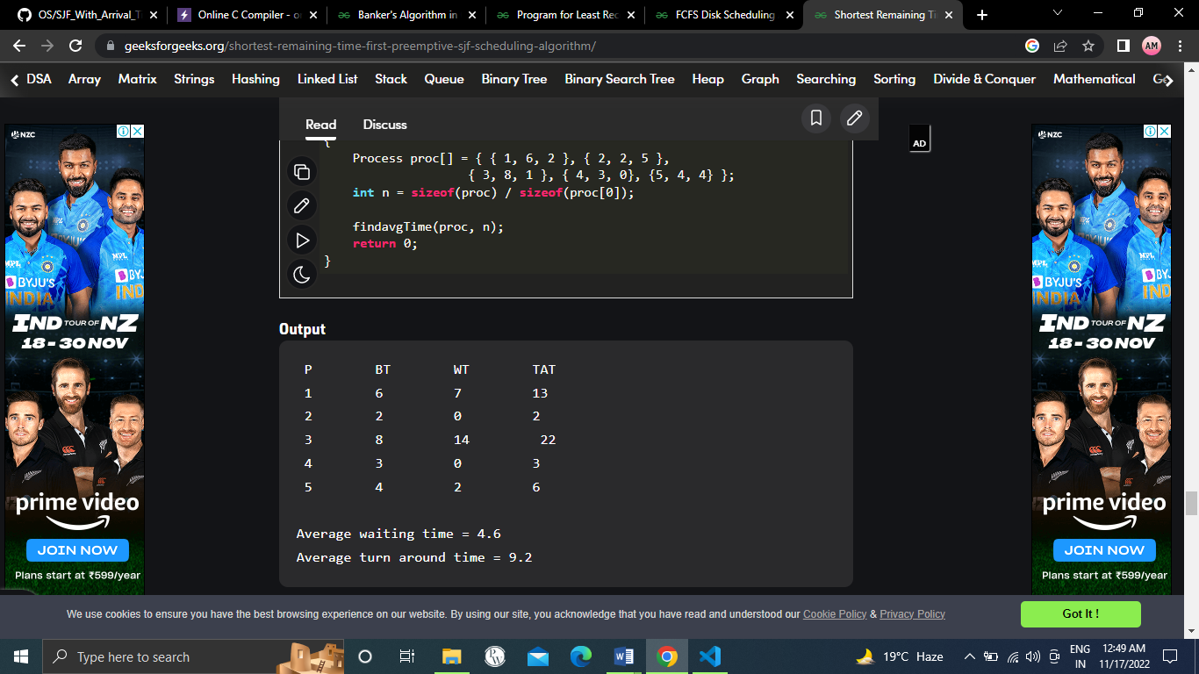

## Result:

Average Waiting Time 4.6……..

Average Turnaround Time 9.2……….

# Experiment-4

## ROUND ROBIN Scheduling

|  |  |  |  |  |  |
| --- | --- | --- | --- | --- | --- |
| Name of Student: Aakash Chouhan | | | | Class: B.tech | |
| Enrollment No:0827CI201002 | | | | Batch: 2020-2024 | |
| Date of Experiment | Date of Submission | | | | Submitted on: |
| Remarks by faculty: | | | Grade: | | |
| Signature of student: | | Signature of Faculty: | | | |

**OBJECTIVE OF THE EXPERIMENT**

To write c program to implement Round Robin scheduling.

## FACILITIES REQUIRED

1. **Facilities Required To Do The Experiment:**

|  |  |  |
| --- | --- | --- |
| **S.NO** | **FACILITIES REQUIRED** | **QUANTITY** |
| **1** | **System** | **1** |
| **2** | **Windows XP/7** |  |

## Concept Of Round Robin Scheduling:

This Algorithm is designed especially for time-sharing systems. A small unit of time, called time slices or **quantum** is defined. All runnable processes are kept in a circular queue. The CPU scheduler goes around this queue, allocating the CPU to each process for a time interval of one quantum. New processes are added to the tail of the queue. The CPU scheduler picks the first process from the queue, sets a timer to interrupt after one quantum, and dispatches the process. If the process is still running at the end of the quantum, the CPU is preempted and the process is added to the tail of the queue. If the process finishes before the end of the quantum, the process itself releases the CPU voluntarily Every time a process is granted the CPU, a **context switch** occurs, this adds overhead to the process execution time.

|  |  |
| --- | --- |
|  | Burst |
| Process | Time |
|  | 24 |
|  | 3 |

|  |  |
| --- | --- |
|  | 3 |
| Average |  |

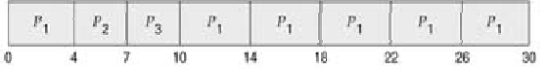

## Algorithm:

Step 1: Start the process

Step 2: Accept the number of processes in the ready Queue and time quantum (or) time slice Step 3: For each process in the ready Q, assign the process id and accept the CPU burst time Step 4: Calculate the no. of time slices for each process where

No. of time slice for process(n) = burst time process(n)/time slice

Step 5: If the burst time is less than the time slice then the no. of time slices =1.

Step 6: Consider the ready queue is a circular Q, calculate

* 1. Waiting time for process(n) = waiting time of process(n-1)+ burst time of process(n-1

) + the time difference in getting the CPU from process(n-1)

* 1. Turn around time for process(n) = waiting time of process(n) + burst time of process(n)+ the time difference in getting CPU from process(n).

Step 7: Calculate

1. Average waiting time = Total waiting Time / Number of process
2. Average Turnaround time = Total Turnaround Time / Number of process Step 8: Stop the process

## Program:

|  |
| --- |
| #include<iostream> |
|  | using namespace std; |
|  | int main() |
|  | { |
|  | int n,to=0; |
|  | cout<<"Enter number of process"<<endl; |
|  | cin>>n; |
|  | int ar[n][2]; |
|  | cout<<"Enter the burst time of each process "<<endl; |
|  | for(int i=0;i<n;i++) |
|  | { |
|  | cin>>ar[i][1]; |
|  | to=to+ar[i][1]; |
|  | ar[i][0]=i+1; |
|  | } |
|  | cout<<"Total = "<<to<<endl<<endl; |
|  | int tq; |
|  | cout<<"Enter time quantum"<<endl; |
|  | cin>>tq; |
|  | int num=0; |
|  | cout<<"*******Gantt Chart*******"<<endl<<endl; |
|  | while(to>0) |
|  | { |
|  | if(ar[num][1]>=tq) |
|  | { |
|  | ar[num][1]=ar[num][1]-tq; |
|  | to=to-tq; |
|  |  |
|  | cout<<num+1<<" "; |
|  | } |
|  | else if(ar[num][1]<tq && ar[num][1]>0) |
|  | { |
|  |  |
|  | to=to-ar[num][1]; |
|  | ar[num][1]=0; |
|  |  |
|  | cout<<num+1<<" "; |
|  | } |
|  | num++; |
|  | if(num==n) |
|  | {num=0;} |
|  |  |
|  | } |
|  |  |
|  | return 0; |
|  |  |

1. **Output:**

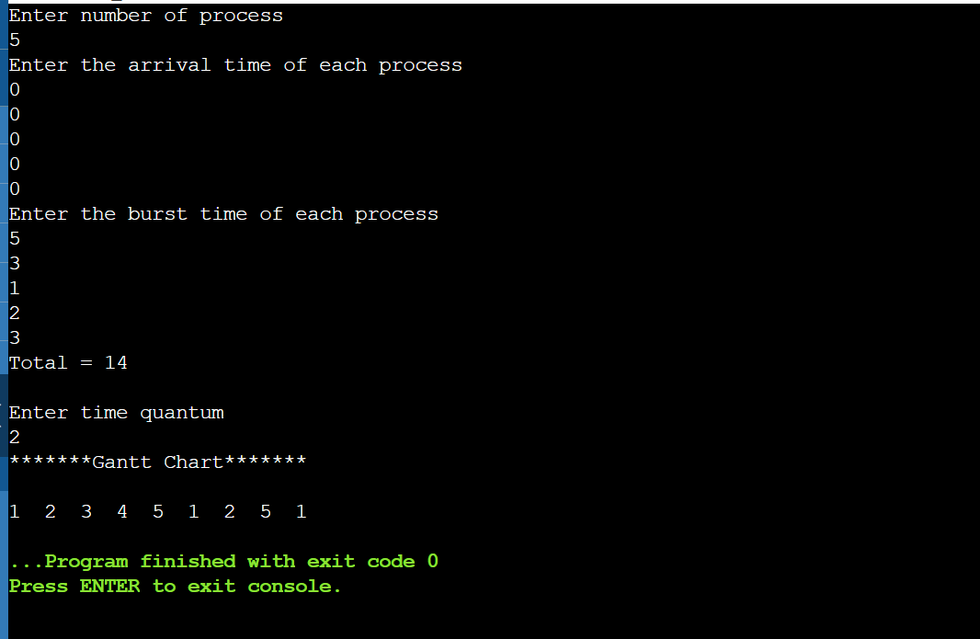

## Result:

Average Waiting Time:- 2

Average Turnaround Time ……….

# Experiment-5

## PRIORITY SCHEDULING

|  |  |  |  |  |  |
| --- | --- | --- | --- | --- | --- |
| Name of Student: Aakash Chouhan | | | | Class: B.tech | |
| Enrollment No:0827CI201002 | | | | Batch: 2020-2024 | |
| Date of Experiment | Date of Submission | | | | Submitted on: |
| Remarks by faculty: | | | Grade: | | |
| Signature of student: | | Signature of Faculty: | | | |

**OBJECTIVE OF THE EXPERIMENT**

To write c program to implement Priority scheduling.

## FACILITIES REQUIRED

1. **Facilities Required To Do The Experiment:**

|  |  |  |
| --- | --- | --- |
| **S.NO** | **FACILITIES REQUIRED** | **QUANTITY** |
| **1** | **System** | **1** |
| **2** | **Windows XP/7** |  |

## Concept Of Priority Scheduling:

A priority is associated with each process, and the CPU is allocated to the process with the highest priority. Equal-priority processes are scheduled in FCFS order.

An SJF algorithm is simply a priority algorithm where the priority (p) is the inverse of the (predicted) next CPU burst. The larger the CPU burst, the lower the priority, and vice versa.

As an example, consider the following set of processes, assumed to have arrived at time 0, in the order

|  |  |  |  |  |
| --- | --- | --- | --- | --- |
|  | Burst |  | Waiting | Turnaround |
| Process | Time | Priority | Time | Time |
|  | 10 | 3 | 6 | 16 |
|  | 1 | 1 | 0 | 1 |
|  | 2 | 4 | 16 | 18 |
|  | 1 | 5 | 18 | 19 |

|  |  |  |  |  |
| --- | --- | --- | --- | --- |
|  | 5 | 2 | 1 | 6 |
| Average | - | - | 8.2 | 12 |

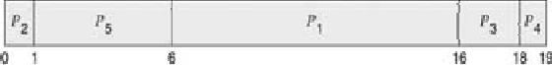

## Algorithm:

Step 1: Start the process

Step 2: Accept the number of processes in the ready Queue

Step 3: For each process in the ready Q, assign the process id and accept the CPU burst time Step 4: Sort the ready queue according to the priority number.

Step 5: Set the waiting of the first process as ‘0’ and its burst time as its turn around time Step 6: For each process in the Ready Q calculate

1. Waiting time for process(n)= waiting time of process (n-1) + Burst time of process(n- 1)
2. Turn around time for Process(n)= waiting time of Process(n)+ Burst time for process(n)

Step 7: Calculate

1. Average waiting time = Total waiting Time / Number of process
2. Average Turnaround time = Total Turnaround Time / Number of process Step 8: Stop the process

## Program:

#include<iostream>

using namespace std;

int main()

{

int bt[20],p[20],wt[20],tat[20],pr[20],i,j,n,total=0,pos,temp,avg_wt,avg_tat;

cout<<"Enter Total Number of Process:";

cin>>n;

cout<<"\nEnter Burst Time and Priority\n";

for(i=0;i<n;i++)

{

cout<<"\nP["<<i+1<<"]\n";

cout<<"Burst Time:";

cin>>bt[i];

cout<<"Priority:";

cin>>pr[i];

p[i]=i+1;

}

for(i=0;i<n;i++)

{

pos=i;

for(j=i+1;j<n;j++)

{

if(pr[j]<pr[pos])

pos=j;

}

temp=pr[i];

pr[i]=pr[pos];

pr[pos]=temp;

temp=bt[i];

bt[i]=bt[pos];

bt[pos]=temp;

temp=p[i];

p[i]=p[pos];

p[pos]=temp;

}

wt[0]=0;

for(i=1;i<n;i++)

{

wt[i]=0;

for(j=0;j<i;j++)

wt[i]+=bt[j];

total+=wt[i];

}

avg_wt=total/n; //average waiting time

total=0;

cout<<"\nProcess\t Burst Time \tWaiting Time\tTurnaround Time";

for(i=0;i<n;i++)

{

tat[i]=bt[i]+wt[i]; total+=tat[i];

cout<<"\nP["<<p[i]<<"]\t\t "<<bt[i]<<"\t\t "<<wt[i]<<"\t\t\t"<<tat[i];

}

avg_tat=total/n;

cout<<"\n\nAverage Waiting Time="<<avg_wt;

cout<<"\nAverage Turnaround Time="<<avg_tat;

return 0;

}

1. **Output:**

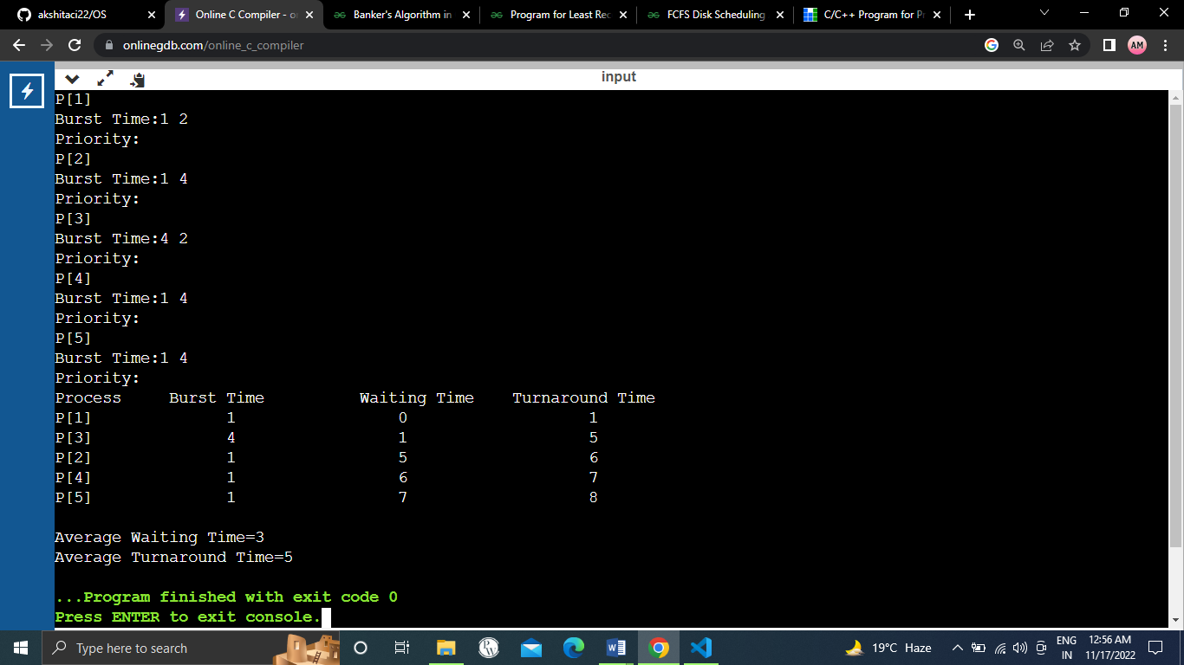

## Result:

Average Waiting Time 3……..

Average Turnaround Time 5……….

# Experiment-6

## BANKER ALGORITHM

|  |  |  |  |  |  |
| --- | --- | --- | --- | --- | --- |
| Name of Student: Aakash Chouhan | | | | Class: B.tech | |
| Enrollment No:0827CI201002 | | | | Batch: 2020-2024 | |
| Date of Experiment | Date of Submission | | | | Submitted on: |
| Remarks by faculty: | | | Grade: | | |
| Signature of student: | | Signature of Faculty: | | | |

**OBJECTIVE OF THE EXPERIMENT**

To write c program to implement deadlock avoidance & Prevention by using Banker’s Algorithm.

## FACILITIES REQUIRED

1. **Facilities Required To Do The Experiment:**

|  |  |  |
| --- | --- | --- |
| **S.NO** | **FACILITIES REQUIRED** | **QUANTITY** |
| **1** | **System** | **1** |
| **2** | **Windows XP/7** |  |

## Concept Of BANKER’S Algorithm:

The Banker's algorithm is a resource allocation and deadlock avoidance algorithm that tests for safety by simulating the allocation of predetermined maximum possible amounts of all resources, and then makes an "s-state" check to test for possible deadlock conditions for all other pending activities, before deciding whether allocation should be allowed to continue.

* + Always keep so many resources that satisfy the needs of at least one client
  + Multiple instances.
  + Each process must a priori claim maximum use.
  + When a process requests a resource it may have to wait.
  + When a process gets all its resources it must return them in a finite amount of time.

## Algorithm:

1. Start the program.
2. Get the values of resources and processes.
3. Get the avail value.
4. After allocation find the need value.
5. Check whether it’s possible to allocate.
6. If it is possible then the system is in safe state.
7. Else system is not in safety state.
8. If the new request comes then check that the system is in safety.
9. Or not if we allow the request.
10. Stop the program.

## Program:

|  |
| --- |
| #include<iostream> |
|  | #include<bits/stdc++.h> |
|  | using namespace std; |
|  |  |
|  | int alloc[50][50]; |
|  |  |
|  | int maxi[50][50]; |
|  |  |
|  | int need[50][50]; |
|  |  |
|  | int avail[50]; |
|  |  |
|  |  |
|  | class Test |
|  | { |
|  |  |
|  | public: |
|  |  |
|  |  |
|  | int check_safety(int j,int nr) |
|  |  |
|  | { |
|  |  |
|  | for(int i=0;i<nr;i++) |
|  |  |
|  | { |
|  |  |
|  | if(need[j][i]>avail[i]) |
|  |  |
|  | return 0; |
|  |  |
|  | } |
|  |  |
|  | return 1; |
|  |  |
|  | } |
|  | int check(bool a[],int n) |
|  |  |
|  | { |
|  |  |
|  | for(int i=0;i<n;i++) |
|  |  |
|  | { |
|  |  |
|  | if(a[i]==false) |
|  |  |
|  | return 0; |
|  |  |
|  | } |
|  |  |
|  | return 1; |
|  |  |
|  | } |
|  | }; |
|  |  |
|  |  |
|  | int main() |
|  |  |
|  | { |
|  | Test t1; |
|  |  |
|  | int np=100; |
|  |  |
|  | int nr=100; |
|  |  |
|  |  |
|  |  |
|  | cout<<"\nEnter the no. of processes : "; |
|  |  |
|  | cin>>np; |
|  |  |
|  | cout<<"\nEnter the no of resources : "; |
|  |  |
|  | cin>>nr; |
|  |  |
|  |  |
|  | cout<<"\nEnter the allocation data : \n"; |
|  |  |
|  | for(int i=0;i<np;i++) |
|  |  |
|  | for(int j=0;j<nr;j++) |
|  |  |
|  | cin>>alloc[i][j]; |
|  |  |
|  |  |
|  |  |
|  | cout<<"\nEnter the requirement data : \n"; |
|  |  |
|  | for(int i=0;i<np;i++) |
|  |  |
|  | for(int j=0;j<nr;j++) |
|  |  |
|  | cin>>maxi[i][j]; |
|  |  |
|  |  |
|  |  |
|  | //Calculation of need matrix |
|  |  |
|  | for(int i=0;i<np;i++) |
|  |  |
|  | for(int j=0;j<nr;j++) |
|  |  |
|  | need[i][j]=maxi[i][j]-alloc[i][j]; |
|  |  |
|  |  |
|  |  |
|  | cout<<"\nEnter the availability matrix : \n"; |
|  |  |
|  | for(int i=0;i<nr;i++) |
|  |  |
|  | cin>>avail[i]; |
|  |  |
|  |  |
|  |  |
|  | int ex_it=nr; |
|  |  |
|  | int flg; |
|  |  |
|  | bool completed[np]; |
|  |  |
|  | while(10) |
|  |  |
|  | { |
|  |  |
|  | for(int i=0;i<np;i++) |
|  |  |
|  | { |
|  |  |
|  | if(!completed[i] && t1.check_safety(i,nr)) |
|  |  |
|  | { |
|  |  |
|  |  |
|  |  |
|  | for(int j=0;j<nr;j++) |
|  |  |
|  | avail[j]+=alloc[i][j]; |
|  |  |
|  | } |
|  |  |
|  | completed[i]=true; |
|  |  |
|  | } |
|  |  |
|  | flg=t1.check(completed,np); |
|  |  |
|  | ex_it--; |
|  |  |
|  | if(flg==1 || ex_it==0) |
|  |  |
|  | break; |
|  |  |
|  | } |
|  |  |
|  |  |
|  |  |
|  | cout<<"\nThe final availability matrix \n"; |
|  |  |
|  | for(int i=0;i<nr;i++) |
|  |  |
|  | cout<<avail[i]<<" "; |
|  |  |
|  |  |
|  |  |
|  | cout<<"\n --------- Result ------------- \n"; |
|  |  |
|  | if(flg==1) |
|  |  |
|  | cout<<"There is no deadlock"; |
|  |  |
|  | else |
|  |  |
|  | cout<<"Sorry there is a possibility of deadlock"; |
|  |  |
|  | return 0; |
|  |  |
|  | } |

1. **Output:**

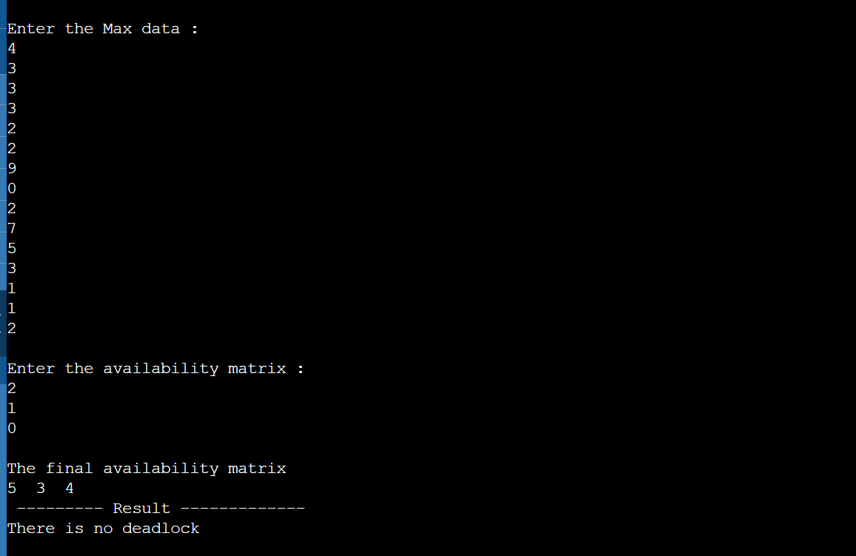

## Result:

The Sequence Is: P1->P4>P0->P2->P3

# Experiment-7

## FIFO PAGE REPLACEMENT

|  |  |  |  |  |  |
| --- | --- | --- | --- | --- | --- |
| Name of Student: Aakash Chouhan | | | | Class: B.tech | |
| Enrollment No:0827CI201002 | | | | Batch: 2020-2024 | |
| Date of Experiment | Date of Submission | | | | Submitted on: |
| Remarks by faculty: | | | Grade: | | |
| Signature of student: | | Signature of Faculty: | | | |

**OBJECTIVE OF THE EXPERIMENT**

To implement page replacement algorithm FIFO.

## FACILITIES REQUIRED

1. **Facilities Required To Do The Experiment:**

|  |  |  |
| --- | --- | --- |
| **S.NO** | **FACILITIES REQUIRED** | **QUANTITY** |
| **1** | **System** | **1** |
| **2** | **Windows XP/7** |  |

## Concept Fifo Page Replacement:

* Treats page frames allocated to a process as a circular buffer:
* When the buffer is full, the oldest page is replaced. Hence first-in, first-out: A frequently used page is often the oldest, so it will be repeatedly paged out by FIFO. Simple to implement: requires only a pointer that circles through the page frames of the process.

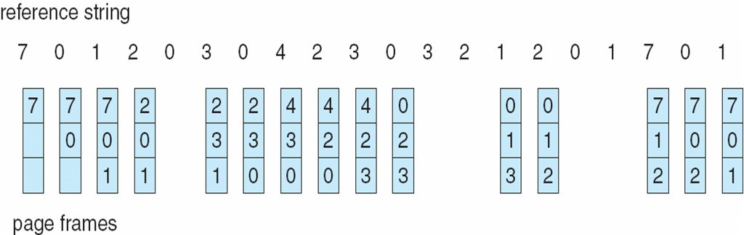

* FIFO Replacement manifests Belady’s Anomaly: more frames  more page faults
* Reference string: 1, 2, 3, 4, 1, 2, 5, 1, 2, 3, 4, 5() 3 Frames:-9 page fault

4 Frames: - 10 page fault

## Algorithm:

Step 1: Create a queue to hold all pages in memory

Step 2: When the page is required replace the page at the head of the queue Step 3: Now the new page is inserted at the tail of the queue

## Program:

|  |
| --- |
| #include<iostream> |
|  | #include<bits/stdc++.h> |
|  | using namespace std; |
|  | int page_fault_FIFO(int pages[] , int n , int c) |
|  | { |
|  | int pagefault=0; |
|  | vector<int> v; |
|  | int i; |
|  | int index=0; |
|  | for(int i=0;i<n;i++) |
|  | { |
|  | auto it = std::find(v.begin() , v.end(),pages[i]); |
|  | if(it==v.end()) |
|  | { |
|  | if(v.size()==c) |
|  | { |
|  |  |
|  | v.erase(v.begin()+(index)); |
|  | } |
|  | // v.push_back(pages[i]); |
|  | v.insert(v.begin(),index); |
|  | index++; |
|  | index=index%c; |
|  | pagefault++; |
|  | } |
|  | else |
|  | {v.erase(it); |
|  | v.push_back(pages[i]); |
|  | } |
|  | } |
|  | return pagefault; |
|  | } |
|  | int main() |
|  | { |
|  | int page[]={7,0,1,2,0,3,0,4,2,3,0,3,2}; |
|  | int n=13; |
|  | int memocapacity=4;  cout<<"Total number of pages are:"<<n<<endl;  cout<<"Total pages are:"<<endl;  for(int i=0;i<n;i++)  cout<<pages[i]<<" ";    cout<<"\nMemory capacity is: "<<memcapacity<<endl; |
|  | cout<<"Total number of page faults are:"<<page_fault_FIFO(page,n,memocapacity)<<endl; |
|  |  |
|  |  |
|  | return 0; |
|  | } |

1. **Output:**

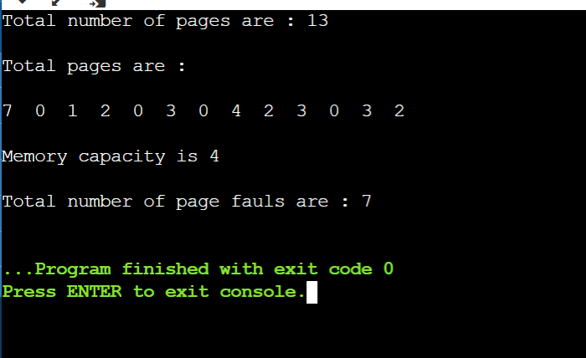

## Result:

No. of page faults = 7

# Experiment-8

## LRU PAGE REPLACEMENT

|  |  |  |  |  |  |
| --- | --- | --- | --- | --- | --- |
| Name of Student: Aakash Chouhan | | | | Class: B.tech | |
| Enrollment No:0827CI201002 | | | | Batch: 2020-2024 | |
| Date of Experiment | Date of Submission | | | | Submitted on: |
| Remarks by faculty: | | | Grade: | | |
| Signature of student: | | Signature of Faculty: | | | |

**OBJECTIVE OF THE EXPERIMENT**

To implement page replacement algorithm LRU.

## FACILITIES REQUIRED

1. **Facilities Required To Do The Experiment:**

|  |  |  |
| --- | --- | --- |
| **S.NO** | **FACILITIES REQUIRED** | **QUANTITY** |
| **1** | **System** | **1** |
| **2** | **Windows XP/7** |  |

## Concept of LRU Algorithm:

Pages that have been heavily used in the last few instructions will probably be heavily used again in the next few. Conversely, pages that have not been used for ages will probably remain unused for a long time. when a page fault occurs, throw out the page that has been unused for the longest time. This strategy is called LRU (Least Recently Used) paging.

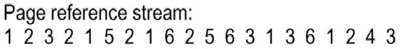

## Algorithm:

Step 1: Create a queue to hold all pages in memory

Step 2: When the page is required replace the page at the head of the queue Step 3: Now the new page is inserted at the tail of the queue

Step 4: Create a stack

Step 5: When the page fault occurs replace page present at the bottom of the stack

## Program:

#include <iostream>

#include<bits/stdc++.h>

using namespace std;

int pageFault(int pages[], int n, int memcapacity){

int pagefault = 0;

vector <int> v;

int i;

for(int i=0;i<=n;i++){

auto it= find(v.begin(), v.end(), pages[i]);

if(it==v.end()){

if(v.size()==memcapacity){

v.erase(v.begin());

}

v.push_back(pages[i]);

pagefault++;

}

else{

v.erase(it);

v.push_back(pages[i]);

}

}

return pagefault;

}

int main() {

int pages[] = {7,0,1,2,0,3,0,4,2,3,0,3,2};

int n=13;

int memcapacity = 4;

cout<<"Total number of pages are:"<<n<<endl;

cout<<"Total pages are:"<<endl;

for(int i=0;i<n;i++)

cout<<pages[i]<<" ";

cout<<"\nMemory capacity is: "<<memcapacity<<endl;

cout<<"Total number of page faults are:"<<pageFault(pages, n, memcapacity);

return 0;

}

1. **OUTPUT:**

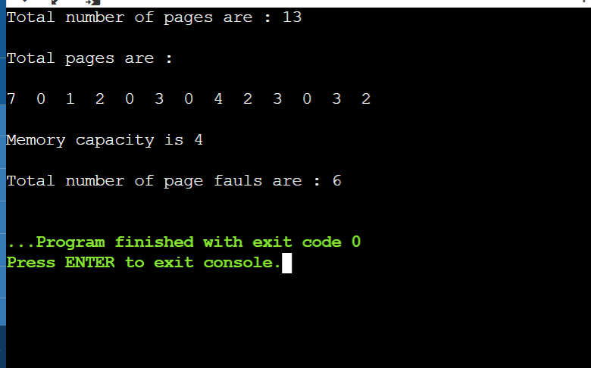

## Result:

No. of pages faults = 6

# Experiment-9

## FCFS Disk Scheduling Algorithm

|  |  |  |  |  |  |
| --- | --- | --- | --- | --- | --- |
| Name of Student: Aakash Chouhan | | | | Class: B.tech | |
| Enrollment No:0827CI201002 | | | | Batch: 2020-2024 | |
| Date of Experiment | Date of Submission | | | | Submitted on: |
| Remarks by faculty: | | | Grade: | | |
| Signature of student: | | Signature of Faculty: | | | |

**OBJECTIVE OF THE EXPERIMENT**

To implement FCFS Disk Scheduling Algorithm

## FACILITIES REQUIRED

* 1. **Facilities Required To Do The Experiment:**

|  |  |  |
| --- | --- | --- |
| **S.NO** | **FACILITIES REQUIRED** | **QUANTITY** |
| **1** | **System** | **1** |
| **2** | **Windows XP/7** |  |

## Concept of FCFS Disk Scheduling Algorithm:

All incoming requests are placed at the end of the queue. Whatever number that is next in the queue will be the next number served. Using this algorithm doesn't provide the best results. To determine the number of head movements you would simply find the number of tracks it took to move from one request to the next. For this case it went from 50 to 95 to 180 and so on. From 50 to 95 it moved 45 tracks. If you tally up the total number of tracks you will find how many tracks it had to go through before finishing the entire request. In this example, it had a total head movement of 640 tracks. The disadvantage of this algorithm is noted by the oscillation from track 50 to track 180 and then back to track 11 to 123 then to 64. As you will soon see, this is the worse algorithm that one can use.

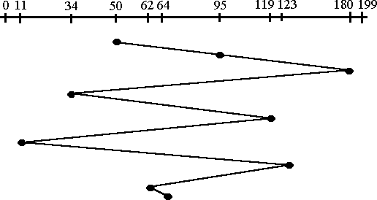

## Algorithm:

Step 1: Create a queue to hold all requests in disk

Step 2: Move the head to the request in FIFO order (Serve the request first that came first) Step 3: Calculate the total head movement required to serve all request.

## Program:

#include<bits/stdc++.h>

using namespace std;

float FCFS(int arr[],int req,int trackes,int ini)

{float sum=0;

for(int i=0;i<req;i++)

{sum+=abs(ini-arr[i]);

ini=arr[i];}

return sum/req;

}

int main()

{

int trackes=200;

int request=9;

int initial=100;

cout<<"Enter total nunmber of tracks";

cin>>trackes;

cout<<"Enter total nunmber of requests";

cin>>request;

cout<<"Enter initial track";

cin>>initial;

int arr[request];

cout<<"Enter requests"<<endl;

for(int i=0;i<request;i++)

{cin>>arr[i];}

cout<<"The average seek time is "<<FCFS(arr,request,trackes,initial);

return 0;

}

**98**

* 1. **Output:**

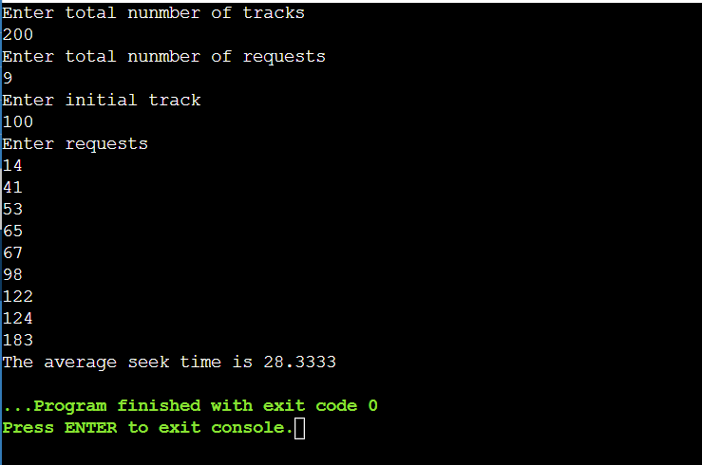

## Result:

Total Head Movement Required Serving All Requests ………

# Experiment-10

## SSTF Disk Scheduling Algorithm

|  |  |  |  |  |  |
| --- | --- | --- | --- | --- | --- |
| Name of Student: Aakash Chouhan | | | | Class: B.tech | |
| Enrollment No:0827CI201002 | | | | Batch: 2020-2024 | |
| Date of Experiment | Date of Submission | | | | Submitted on: |
| Remarks by faculty: | | | Grade: | | |
| Signature of student: | | Signature of Faculty: | | | |

**OBJECTIVE OF THE EXPERIMENT**

To implement SSTF Disk Scheduling Algorithm

## FACILITIES REQUIRED

1. **Facilities Required To Do The Experiment:**

|  |  |  |
| --- | --- | --- |
| **S.NO** | **FACILITIES REQUIRED** | **QUANTITY** |
| **1** | **System** | **1** |
| **2** | **Windows XP/7** |  |

## Concept of SSTF Disk Scheduling Algorithm:

In this case request is serviced according to next shortest distance. Starting at 50, the next shortest distance would be 62 instead of 34 since it is only 12 tracks away from 62 and 16 tracks away from 34. The process would continue until all the process are taken care of. For example the next case would be to move from 62 to 64 instead of 34 since there are only 2 tracks between them and not 18 if it were to go the other way. Although this seems to be a better service being that it moved a total of 236 tracks, this is not an optimal one. There is a great chance that starvation would take place. The reason for this is if there were a lot of requests close to each other the other requests will never be handled since the distance will always be greater.

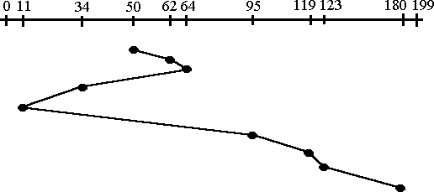

## Algorithm:

Step 1: Create a queue to hold all requests in disk

Step 2: Calculate the shortest seek time every time before moving head from current head position

Step 3: Calculate the total head movement required to serve all request.

## Program:

#include <iostream>

#include <bits/stdc++.h>

using namespace std;

float SSTF(vector<int> v1,int req,int ini)

{

int index=-1;

for(int j=0;j<v1.size();j++)

{

if(v1[j]==ini)

{index=j;break;}

}

float sum=0,k=1;

while(true)

{

for(int j=0;j<v1.size();j++)

{

cout<<v1[j]<<" ";

}

if(index==0 && v1.size()>=2)

{cout<<" // "<<v1[index+1]<<" - "<<v1[index];

sum+=abs(v1[index+1]-v1[index]);

ini=v1[index+1];

v1.erase(v1.begin()+index);

}

else if(index==v1.size()-1 && v1.size()>=2)

{cout<<" // "<<v1[index]<<" - "<<v1[index-1];

sum+=abs(v1[index]-v1[index-1]);

ini=v1[index-1];

v1.erase(v1.begin()+index);}

else if(v1.size()==1)

{cout<<v1[0];break;}

else if(abs(v1[index+1]-v1[index])<=abs(v1[index]-v1[index-1]))

{

cout<<" // "<<v1[index+1]<<" - "<<v1[index];

sum+=abs(v1[index+1]-v1[index]);

ini=v1[index+1];

v1.erase(v1.begin()+index);

}

else if((abs(v1[index+1]-v1[index]))>abs((v1[index-1]-v1[index])))

{

cout<<" // "<<v1[index]<<" - "<<v1[index-1];

sum+=abs(v1[index]-v1[index-1]);

ini=v1[index-1];

v1.erase(v1.begin()+index);

}

if(v1.size()==1)

{break;}

for(int j=0;j<v1.size();j++)

{

if(v1[j]==ini)

{index=j;break;}

}cout<<" "<<sum<<" ";

cout<<endl;

}

for(int j=0;j<v1.size();j++)

{

cout<<" "<<v1[j]<<" ";

}

return sum/req;

}

int main()

{

int trackes=200;

cout<<"Enter the number of total trackes"<<endl;

cin>>trackes;

int request=9;

cout<<"Enter the number of requests"<<endl;

cin>>request;

int initial=100;

cout<<"Enter the initial track value"<<endl;

cin>>initial;

vector<int> v1;

int arr[request];

v1.push_back(initial);

int n;

cout<<"Enter the value of the requested trackes"<<endl;

for(int i=0;i<request;i++)

{cin>>n;

v1.push_back(n);

}

sort(v1.begin(),v1.end());

float ans=SSTF(v1,request,initial);

cout<<endl<<endl<<"Average seek time = "<<ans;

return 0;

}

1. **Output:**

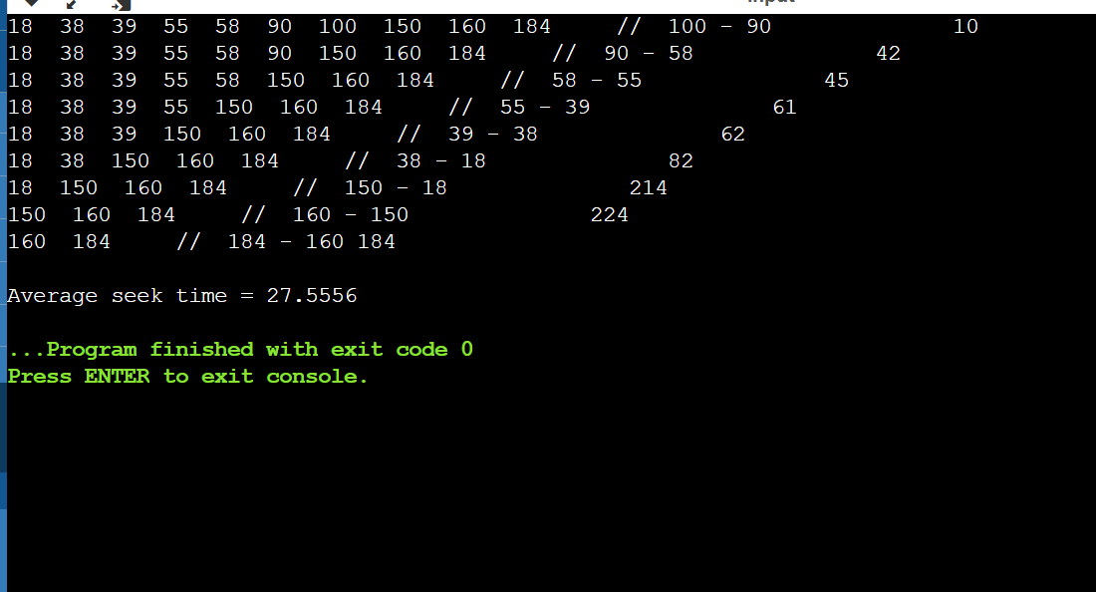

## Result:

Total Head Movement Required Serving All Requests …….

**FAQ’s**

* 1. What are different types of schedulers?
  2. Explain types of Operating System?
  3. Explain performance criteria for the selection of schedulers?
  4. Explain priority based preemptive scheduling algorithm?
  5. What is thread?
  6. Explain different types of thread?
  7. What is kernel level thread?
  8. What is user level thread?
  9. What is memory management?
  10. Explain Belady's Anomaly.
  11. What is a binary semaphore? What is its use?
  12. What is thrashing?
  13. List the Coffman's conditions that lead to a deadlock.
  14. What are turnaround time and response time?
  15. What is the Translation Lookaside Buffer (TLB)?
  16. When is a system in safe state?
  17. What is busy waiting?
  18. Explain the popular multiprocessor thread-scheduling strategies.
  19. What are local and global page replacements?
  20. In the context of memory management, what are placement and replacement algorithms?
  21. In loading programs into memory, what is the difference between load-time dynamic linking and run-time dynamic linking?
  22. What are demand- and pre-paging?
  23. Paging a memory management function, while multiprogramming a processor management functions, are the two interdependent?
  24. What has triggered the need for multitasking in PCs?
  25. What is SMP?
  26. List out some reasons for process termination.
  27. What are the reasons for process suspension?
  28. What is process migration?
  29. What is an idle thread?
  30. What are the different operating systems?
  31. What are the basic functions of an operating system?